Syrian Arab Republic
Syrian Private University
Faculty of System security & computer network
Cloud IDS
(Intrusion Detection Systems)

Prepared by :
Nawar Daher
Obeida Fattouh
Mohhamad Hakmeh

Supervised by :
Dr. Wasim Junaidi
Eng. Ahmad Shekha

March 2026

Table of Contents
Contents
CHAPTER 1 introduction 5
1.1Introduction: 6
1.2problem definition: 6
1.3Project goal: 6
CHAPTER 2 7
Reference study 7
2.1 intro: 8
2.2 Cloud Definition 8
2.3 IaaS 8
2.4 PaaS 8
2.5 SaaS 8
2.6Kubernetes (k8s) 10
2.7 K9s 10
2.8 K3s 10
2.9IDS: 11
2.10 Types of IDS 11
2.11 Mechanism of IDS: 11
2.12 Importance in Cloud: 11
2.13 Falco 12
2.14 Falco Rules and Principles Rule Format: 12
2.15 What sets it apart from other detection systems: 12
2.16 File browser 13
2.17 Popular Features: 13
2.18 The security service that provides a cloud file browser (cloud file browser): 13
2.19 Conclusion: 14
CHAPTER 3 15
proposed system 15
3.1Intro 16
3.2 Choosing the Work Environment and Operating System 16
3.3Cloud Environment Component : 16
3.4Choosing and downloading a cloud-based intrusion detection system: 18
3.5Downloading the Business Performance Measurement Tools 18
3.5Cloud file storage: 18
3.6Conclusion 20
CHAPTER 4 21
Implementation 21
4.1 intro 22
4.2Two VMs have been created, 22
4.3 Container images for K3s 22
4.4Falco intrusion detection system 23
4.5 23
4.6 Load testing using my tools k6 24
4.8 conclusion : 26
CHAPTER 5 27
conclusion 27
5.1 intro 28
5.2 SUMMER OF RESULTS: 28
References : 29

Abstract:
Intrusion Detection Systems (IDSes) are extensively used to detect potential threats within guest virtual machines (VMs). However, conventional IDSes often struggle to fulfill the stringent needs of high-performance cloud environments. Firstly, the process of monitoring VM events tends to increase the tail latency experienced by guest services. Secondly, the throughput capacity of traditional IDS solutions is insufficient for the high volume of events generated in such clouds, resulting in missed detections and compromised accuracy. Lastly, many cloud providers implement sophisticated IDS tools directly inside the VMs, which makes updating and maintaining these systems challenging, as any new functionality or improvements necessitate modifications to the guest VMs themselves
Currently, the importance of Intrusion Detection Systems (IDS) has grown significantly, especially with the increasing variety and sophistication of cyber threats targeting cloud infrastructure and digital services. Detecting attacks such as intrusions, malware, and persistent advanced threats has become essential to ensure data security and system integrity. Additionally, international regulations and standards, such as data protection and privacy laws, require organizations to implement stringent measures for early threat detection and effective response. Therefore, developing IDS that can adapt to high-performance cloud environments and provide a high level of security and efficiency is a critical factor for ensuring business continuity and safeguarding vital assets in today’s digital age.

تُستخدم أنظمة كشف التسلل (IDS) على نطاق واسع للكشف عن التهديدات المحتملة داخل الأجهزة الافتراضية الضيفة. ومع ذلك، غالبًا ما تواجه أنظمة كشف التسلل التقليدية صعوبة في تلبية المتطلبات الصارمة لبيئات الحوسبة السحابية عالية الأداء. أولًا، تميل عملية مراقبة أحداث الأجهزة الافتراضية إلى زيادة زمن الاستجابة الذي تعاني منه الخدمات الضيفة. ثانيًا، لا تكفي سعة معالجة البيانات لحلول أنظمة كشف التسلل التقليدية للتعامل مع الحجم الكبير للأحداث المتولدة في هذه البيئات السحابية، مما يؤدي إلى عدم اكتشاف بعض الأحداث وانخفاض دقة الكشف. أخيرًا، يقوم العديد من مزودي خدمات الحوسبة السحابية بتطبيق أدوات كشف التسلل المتطورة مباشرةً داخل الأجهزة الافتراضية، مما يجعل تحديث هذه الأنظمة وصيانتها أمرًا صعبًا، حيث تتطلب أي وظائف جديدة أو تحسينات إجراء تعديلات على الأجهزة الافتراضية الضيفة نفسها.
كما تزايدت أهمية أنظمة كشف التسلل (IDS) بشكل ملحوظ في الوقت الراهن، لا سيما مع تزايد تنوع وتعقيد التهديدات السيبرانية التي تستهدف البنية التحتية السحابية والخدمات الرقمية. وأصبح كشف الهجمات، كالتسلل والبرمجيات الخبيثة والتهديدات المتقدمة المستمرة، ضروريًا لضمان أمن البيانات وسلامة النظام. إضافةً إلى ذلك، تتطلب اللوائح والمعايير الدولية، كقوانين حماية البيانات والخصوصية، من المؤسسات تطبيق إجراءات صارمة للكشف المبكر عن التهديدات والاستجابة الفعّالة لها. لذا، يُعدّ تطوير أنظمة كشف التسلل القادرة على التكيف مع بيئات الحوسبة السحابية عالية الأداء، وتوفير مستوى عالٍ من الأمان والكفاءة، عاملًا حاسمًا لضمان استمرارية الأعمال وحماية الأصول الحيوية في عصرنا الرقمي.

CHAPTER 1
introduction

1.1Introduction:
In today's world, where reliance on cloud computing is continually increasing, organizations depend heavily on cloud infrastructure to store data and run applications and services. As dependence on the cloud grows, new challenges related to information security and sensitive data protection have emerged, with cyber-attacks evolving constantly to target cloud environments specifically. Consequently, there is a growing need for advanced and effective systems to monitor and detect threats and attacks in cloud environments quickly and reliably. This is where the Cloud Intrusion Detection System (Cloud IDS) project comes into play, offering a modern solution to address these challenges and enhance security levels within cloud computing environments.

1.2problem definition:
This project faces several fundamental issues related to traditional detection systems: as they are unable to meet the demands of high-performance data processing. This is due to the limited processing rate of these traditional systems, which does not satisfy the fast and accurate detection requirements in high-performance environments. As a result, important events may be missed, and the overall detection accuracy is reduced, negatively impacting the system's effectiveness.

1.3Project goal:
    - Study and design of intrusion detection systems (IDS) architectures and their operational mechanisms in cloud environments, with the aim of understanding and analyzing their capabilities in detecting and responding to security threats within these environments.
    - Simulation of a cloud environment at the virtual level to evaluate and study issues related to processing large data volumes and requests, as well as analyzing challenges associated with event loss in intrusion detection systems, in order to improve system performance and increase accuracy in threat detection.

CHAPTER 2

Reference study

2.1 intro:
This section provides a theoretical overview of the relationship between cloud concepts (IaaS, PaaS, and SaaS), the principles of Internet Survey Definition Systems (ISS), and the use of the Falco system in a cloud environment. It also covers the concept of a secure cloud environment, its fundamentals, and its security. The discussion will explore how service model selection aligns with security and choice requirements, and how these elements impact system design, development costs, and operational expenses.

2.2 Cloud Definition
According to NIST's definition, the cloud is defined as a model for providing computing resources (such as servers, storage, and applications) on demand through technical interfaces, taking into account key characteristics: scalability, service-by-service management, and deployment flexibility (public, private, hybrid), in addition to specific security and compliance frameworks. This definition links the concept of services (IaaS/PaaS/SaaS)
  - IaaS (Infrastructure as a Service): Providing a cloud-based infrastructure that defines a virtual location, storage, and network. It uses an infrared electronic controller. Examples: Amazon EC2, Microsoft Azure Virtual Machines, Google Compute Engine.

  - PaaS (Platform as a Service): Providing an application development and operation platform with internet-based management and updates, allowing developers to focus on programming and integration. Examples: Google App Engine, Microsoft Azure Application Services, Heroku.

  - SaaS (Software as a Service): Providing online applications without formal infrastructure for managing personal data or the platform. Examples: Google Workspace, Microsoft 365, Salesforce.
Kubernetes: is an open-source system for managing and coordinating the operation of application containers across multiple computing environments.

Cluster Structure: Consists of control planes and worker nodes. Key Components: Pods (basic container units), Deployments (deployment and update management), Services (application access interface), ConfigMaps and Secrets (control of settings and sensitive data). Operation: kube-apiserver, etcd as a central database, kube-scheduler for node selection, controllers for managing desired state, kubelet on nodes, kube-proxy for network management. Deployment Management: Via YAML/JSON definitions and kubectl as a controller. Scaling and Recovery: Supports autoscaling, automatic reconfiguration, and load distribution via Services and Ingress.

For Security and Compliance: Access Control: RBAC and resource permissions.
Network Policies: Network policies to restrict movement between containers.
Container Security: Pod Security Standards, image scanning, and security updates.
Secret Handling: Secrets and their encryption during transmission and storage.
Cryptography and Identity: TLS for components and necessary component authentication.

2.6Kubernetes (k8s)
The most comprehensive platform for managing and orchestrating application containers across multiple environments.
It orchestrates the automated deployment, scaling, updating, and maintenance of containers.

2.7 K9s
An interactive CLI for managing Kubernetes clusters more dynamically and easily from the command line.
it displays resources and allows for quick navigation between them, with fast commands for accessing and updating.

2.8 K3s
A lightweight Kubernetes distribution designed for resource-constrained environments like Edge and on-premises development.
It provides a complete Kubernetes experience with a simpler installation option and less complex configuration, using SQLite by default and a swappable database.

2.9IDS:
2.10 Types of IDS:
- Basic Types Network-Based IDS (NIDS): Monitors traffic across networks and interfaces.
- Host-Hosted IDS (HIDS): Monitors the activity of the system itself (files, logs, processes).
- Integrated IDS/IPS: Combines detection, response, and prevention capabilities into a single solution.

2.11 Mechanism of IDS:
- Monitoring: Compares real-time data with known safe models and attacks.
- Analysis: Uses signature-based prediction, machine learning, and anomaly-based behavior analysis.
- Alert and Response: Sends notifications and logs, and helps inform intrusion response policies.
Common examples: Network-based IDS (NIDS) and Hosted IDS (HIDS), as well as IDS/IPS systems integrated into some solutions.

2.12 Importance in Cloud:
Environments Protecting the access and data layer across SaaS/PaaS/IaaS services and applications. Detecting unauthorized activity across multiple pathways (virtual networks, containers, applications). Enhancing compliance and governance through security logging and rapid remediation solutions. Adapting to evolving threats and ensuring operational flexibility across multi-region deployments.

2.13 Falco
How it works :
Runtime monitoring: Operates on top of the Kutns kernel layer via an event-listening mechanism, covering the behavior of containers and their hosts.
Customizable rules: Uses a set of (warning) rules that detect unusual behavior such as unauthorized file modifications or out-of-band operations.
Alert technologies: Records alerts and sends them to SIEM systems or other alerting tools, facilitating automated response.
Integration and extension: Seamlessly integrates with Kubernetes and DevOps processes, and supports extracting examples from MITRE ATT&CK in analysis environments.

2.14 Falco Rules and Principles Rule Format:
Expresses a specific event (opening a sensitive file or executing an unauthorized command) with time or contextual conditions. Rule Management: Built-in default rules can be run and modified, and custom rules can be added to suit your environment. Implementation: Operates as a proxy element (Falco daemon) or across multiple blocks in large environments.

2.15 What sets it apart from other detection systems:

Runtime focus: It monitors behavior in the real-time environment, not just for post-processing analysis.
Container and hybrid system support: Designed to work efficiently with Kubernetes, containers, and Linux systems.
Easy customization: Customizable rules and deep integration with SIEM and SOAR tools.
Not just signature-based: It enhances inference with real-time behavior and patterns.

2.16 File browser
How it works:
Background storage: Relies on a cloud provider that stores files as objects with specific paths and access links. Viewing interface: Provides a graphical interface similar to a file explorer for browsing and interacting with folders and files. Permissions and sharing: Supports access permissions, link sharing, and access control mechanisms. Basic operations: Upload, download, create folders, delete, rename, search, and move.

2.17 Popular Features:
Easily view and organize files using simple folder structures. Drag and drop functionality, and batch uploads. Access control and encryption during transfer and storage. Quick search and filtering by type, size, and date. Integration with other cloud tools (SIEM, CI/CD, backup systems).

2.18 The security service that provides a cloud file browser (cloud file browser):
1-Access and Identity Control User authentication on sessions Precise deployment across roles and permissions on resources Multi-Factor Authentication (MFA) support .
2-Data Encryption and Protection Teleread-in-Transit (TLS) Teleread-in-Atom (AES/Other depending on the provider) Key management via KMS services.
3-Trace and Persistence Log of Japanese user actions (audit logs) Access, change, and download reports Support for core standards (e.g., GDPR, HIPAA depending on context)
4-Tracking and Compliance User activity and process logging (Audit logs) Access, change, and download reports Compliance standards support (e.g., GDPR, HIPAA as contextual)
5-Link and Temporary Access Management Pre-signed URLs for sharing control Modified and trackable sharing permissions 6-Security and Configuration Policies Bucket/Object policies Compliance checks and configuration checks Alerts for unusual activity or unauthorized access.
7-Tamper and Data Loss Protection Versioning support for restoring previous versions Protection against accidental deletion (Object lock/immutability on some providers) 8-Network Integrity and Security Isolating networks and applications between S3/GCS/Azure environments Access control via network standards (VPC endpoints, firewall rules)

2.19 Conclusion:
This section covers several important terms, including: basic definitions of cloud and its IaaS/PaaS/SaaS services; deployment models; Kubernetes fundamentals with examples of the K9s tool and the K3s option; Falco and IDS systems; and security in cloud environments. It also discusses potential examples and comparisons, as well as source options for references and documentation in addition of file browser and how it works

CHAPTER 3

proposed system

3.1Intro: This section presents cloud environment simulation models with the addition of a FALCO protocol detection system for monitoring events and attacks, along with the selection of appropriate tools for it. The background is based on working on the system before and after security events in the environment.
work flow and project phase:

3.2 Choosing the Work Environment and Operating System
A virtual machine (VM) was chosen to achieve complete environmental isolation between the development, testing, and production environments. This also allows for rapid replication and backup, and isolated experimentation without impacting other systems. The VM platform is used because it offers scalability, flexible resource management, and maintenance
For the operating system, Ubuntu 64-bit was chosen for its open framework, ease of management, availability of modern packages, and extensive support for security libraries, data analysis tools, and live data streams. Ubuntu 64-bit enables seamless integration with containers and cloud services, provides an active support community, and offers regular security updates, thus enhancing the stability of the proposed system and its compliance with security standards. Choosing this environment supports rapid development, compatibility with monitoring and auditing tools, and streamlined deployment and update
processes throughout the development phases

3.3Cloud Environment Component :
Selection Kubernetes was chosen as the management framework for coordinating and managing system components, with a lightweight distribution like K3S used to simulate a cloud environment with limited resources and simplify node management and development. Two virtual models were designed to represent the cloud architecture:
a master node representing the central server for service management and incident detection.
worker node representing the cloud client where containers run and traffic is routed. This configuration enables realistic simulation of load distribution, resource management, and the enforcement of security and compliance policies within resource constraints, with the ability to scale incrementally as the project evolves. The system also supports reduced configuration and testing time, as well as enhanced operational stability through task isolation and easy service migration between nodes.

3.4Choosing and downloading a cloud-based intrusion detection system:
Falco was selected as our Cloud Intrusion Detection (IDS) solution due to its robust monitoring capabilities in sensitive cloud environments and its ease of adaptation to reconfigurable infrastructure. Falco's functionality was thoroughly analyzed; it relies on monitoring system events and anomalous behavior through updatable behavioral rules and offers seamless integration with container platforms and cloud service applications. Falco's core rules and their respective tiers were analyzed and documented, and a policy framework was developed that addresses security and compliance requirements, enabling the implementation of real-time notifications and the generation of audit reports. Based on this analysis, we concluded that choosing Falco contributes to reduced intrusion response times, improved security visibility, and a scalable and updatable mechanism that adapts to the evolving cloud environment and threat landscape.

3.5Downloading the Business Performance Measurement Tools
(k6 and stress-ng) :
The k6 tool was selected as an open-source load measurement tool to test the performance of APIs and cloud services with realistic response time reports and request flows, while stress-ng is used to measure system stability and resource tolerance by generating system-wide composite loads and evaluating their impact on responsiveness and security.
Both tools will be built in two phases:
1-the first before a sufficient number of security events occur on the Falco system to measure baseline performance and analyze scope.
2-the second after security events occur to deepen understanding of the impact of limitations and threats on detection efficiency and response time reduction.
The use of these two tools aims to provide comparable measurements that help assess the effectiveness of an intrusion detection system when cloud services operate alongside real loads and under multiple security pressures.

3.5Cloud file storage:
This project offers a cloud storage service with various add-ons and file uploads via a dedicated interface. Files are stored in a secure, encrypted database before being saved. The core process involves translating files before saving them and storing them as binary assets with metadata for precise optimization (owner, time period, file type, etc.). This ensures content protection even in the event of a system breach.
This design aims to support ease of retrieval and searching while maintaining regulatory compliance and providing a framework that can be studied in the project in terms of performance, security and reliability.
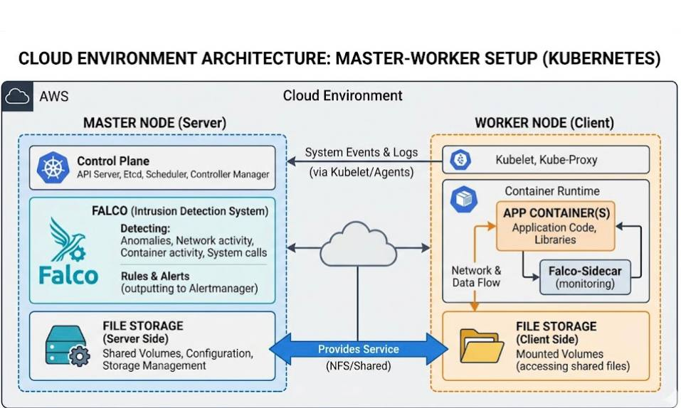

3.6Conclusion:
The project was built in a virtual environment based on the 64-bit Ubuntu operating system, where the K3s container was chosen as a suitable type for running services within a cloud architecture and facilitating deployment and management with limited resources. Subsequently, a cloud intrusion detection system and workload measurement tools were installed on the server to monitor anomalies and accurately analyze performance in two consecutive phases: the first before any security events or breaches are detected by the IDS systems, and the second simultaneously with the occurrence of such events and the application of cloud storage services.
This allows for measuring the impact of security oversight on service stability and performance efficiency. In the first phase, the system focuses on establishing monitoring lines, configuring threat prediction rules, and ensuring the readiness of transmission channels and APIs. The second phase aims to provide real-time, integrated monitoring with continuous operation, thereby enhancing risk detection and mitigation during upload and storage traffic on the cloud storage service. The design relies on integrating a scalable container layer with advanced monitoring mechanisms, enabling horizontal container expansion and integration with the pre-stored encrypted storage system. Furthermore, it ensures workload measurement and performance evaluation systems that support compliance and security verification over time.

CHAPTER 4

Implementation

4.1 intro
In this chapter, we present the practical implementation of our proposed system. The process consists
of the following key stages:
4.2Two VMs have been created, and a 64-bit Ubuntu operating system image has been downloaded on each VM.
4.3 Container images for K3s have been downloaded on both virtual machines, and the master node is considered the server node, while the worker node is the client node.

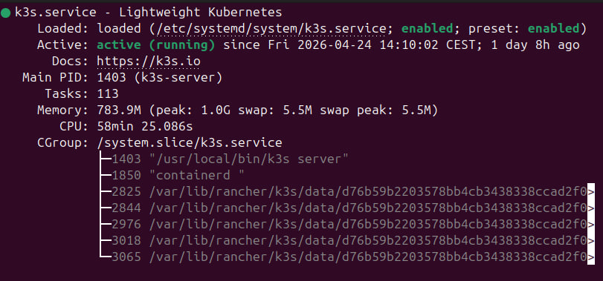
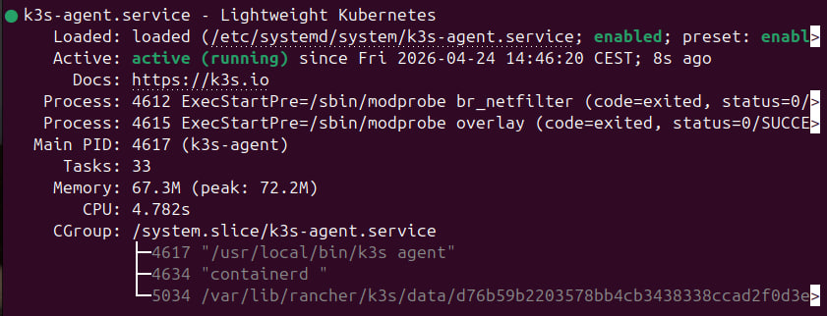

4.4Falco intrusion detection system, along with its rule file and configuration, has been downloaded on the cloud server or on the master node.
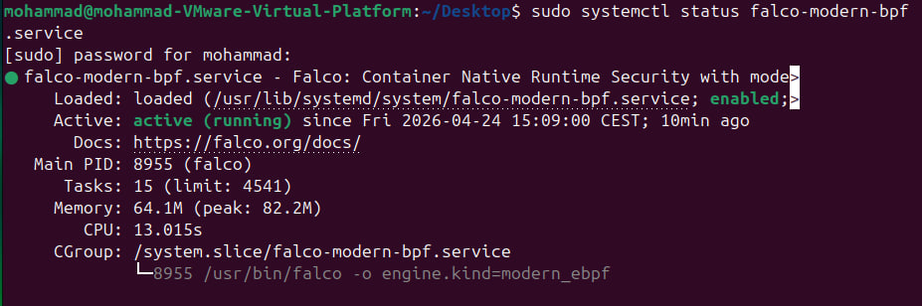

4.5Choosing, downloading, and enabling a cloud file storage service to offer it as a service from the cloud server to the client.

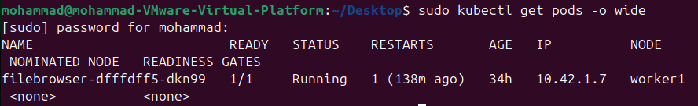

4.6 Load testing using my tools k6 and stress-ng before carrying out an attack on the cloud server.
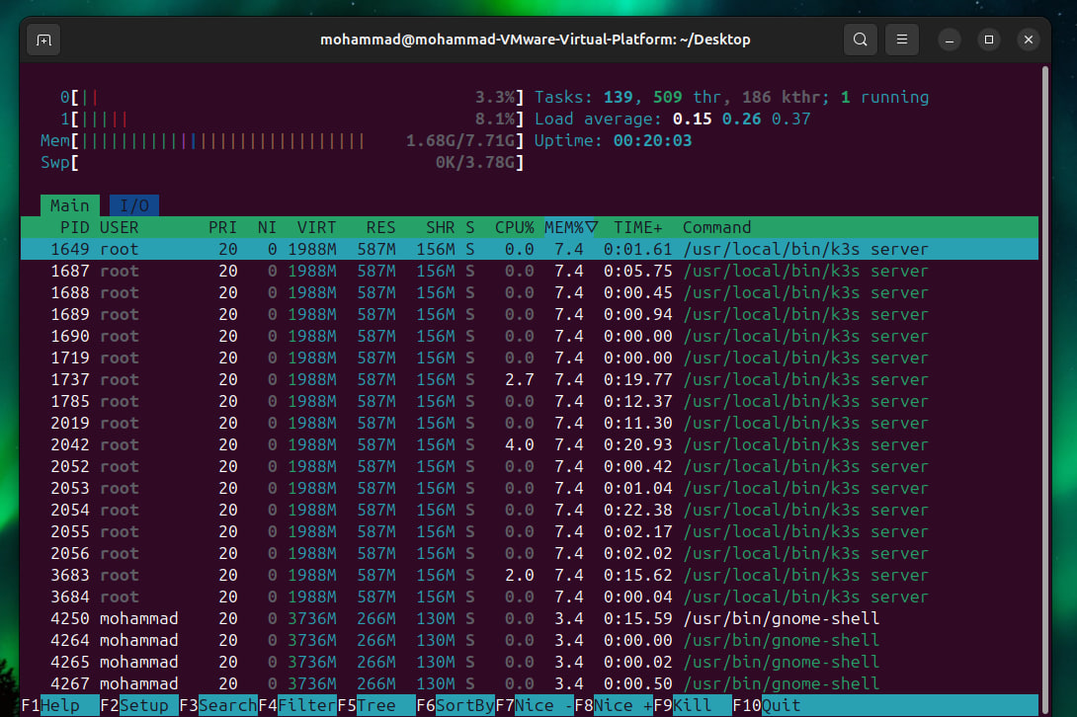

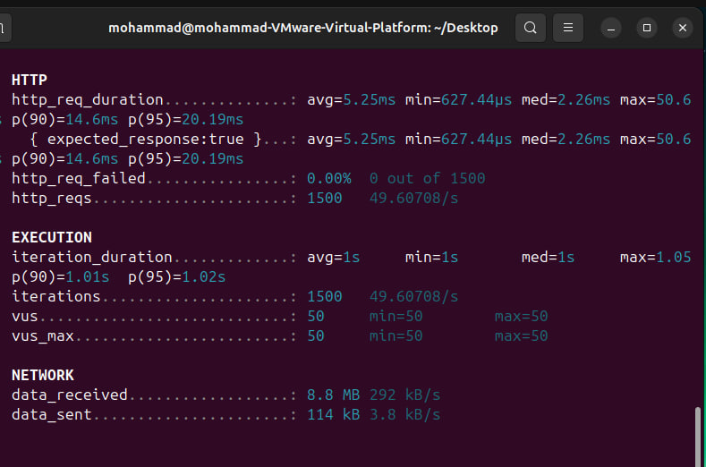
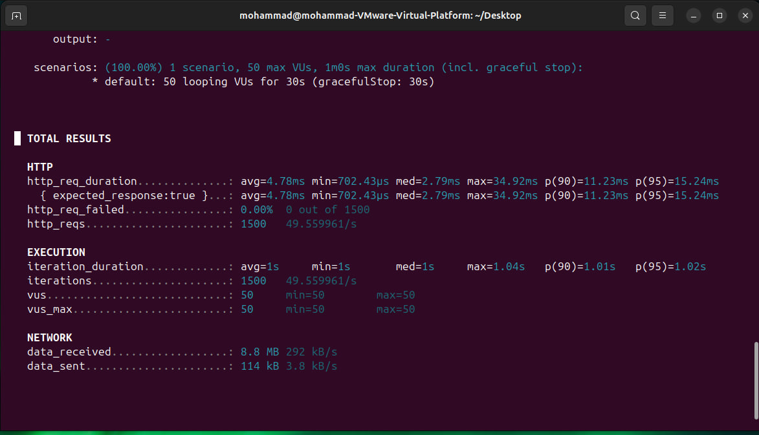
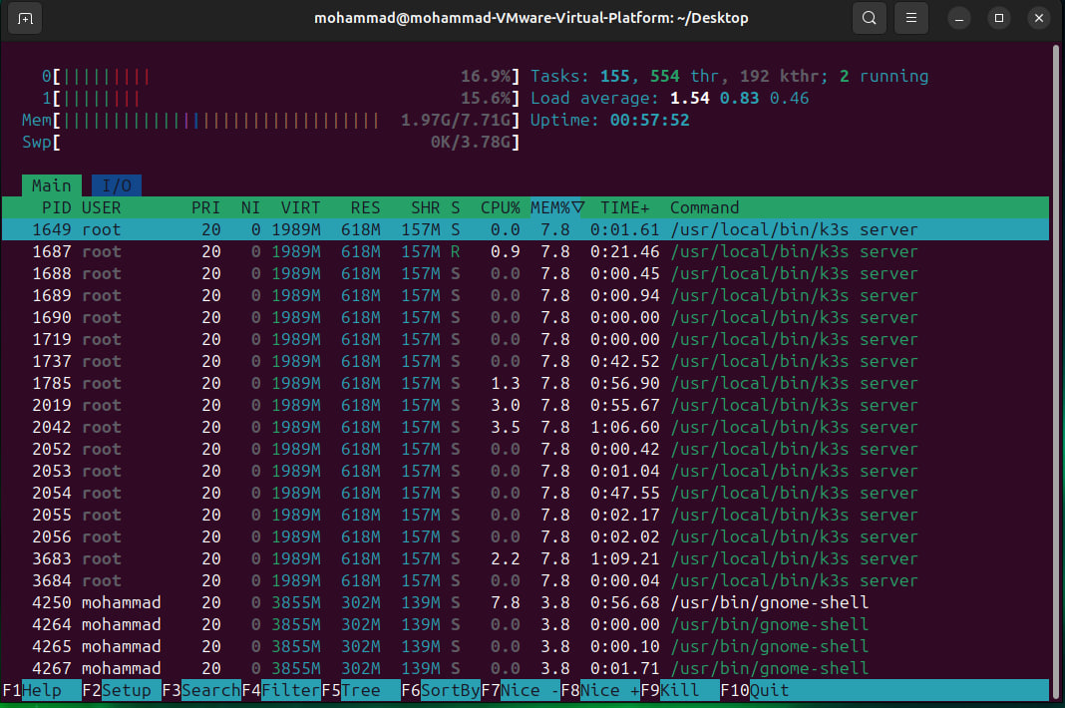
4.7Load testing using my tools k6 and stress-ng after carrying out an attack on the cloud server.

 | Before | After
CPU Usage | 3% – 8% | 15% – 17%
Memory Usage | 1.68 GB | 1.97 GB
Load Average | 0.15 | 1.54
Response Time (avg) | 5.25 ms | 4.78 ms
Max Response Time | 50.6 ms | 34.9 ms
Requests/sec | ~49.6 req/s | ~49.5 req/s
Failed Requests | 0% | 0%
Attack Detection | ❌ غير موجود | ✅ موجود (Falco)

4.8 conclusion :
In this chapter, we successfully implemented and validated the full pipeline of our proposed system.
From building the cloud environment and the ids on cloud server in addition of enabling the file storage and built a successful load test on the mater node at al

CHAPTER 5

conclusion

5.1 intro
This section reviews the findings from the cloud storage service project, where the results showed that the presence of the Falcon threat detection system enhances data protection and compliance, while having a limited impact on performance in cases of security events occurring concurrently with monitoring and analysis operations.

5.2 SUMMER OF RESULTS:
The project's findings summary shows that the presence of cloud intrusion detection systems has a relative impact on cloud service performance during security incidents. According to the outputs of previously used workload measurement tools, processing and response speeds decrease during threat periods as the workload from monitoring, analysis, and threat prediction increases, potentially leading to missed incidents or a temporary decrease in recovery accuracy.

References :
Mell, P., & Grance, T. (2011). The NIST Definition of Cloud Computing.
National Institute of Standards and Technology (NIST).
Burns, B., Hightower, K., & Beda, J. (2017). Kubernetes: Up and Running.
O'Reilly Media.
NIST. (2007). Guide to Intrusion Detection and Prevention Systems (SP 800-94).
National Institute of Standards and Technology.
Sysdig. (n.d.). Falco Documentation.
Retrieved from https://falco.org
Rancher Labs. (n.d.). K3s Documentation.
Retrieved from https://k3s.io
K9s Project. (n.d.). K9s - Kubernetes CLI Tool Documentation.
Amazon Web Services. (n.d.). Amazon EC2 Documentation.
Microsoft. (n.d.). Azure Virtual Machines Documentation.
Google Cloud. (n.d.). Google Compute Engine Documentation.
Salesforce. (n.d.). Salesforce Platform Overview.
Google. (n.d.). Google Workspace Documentation.
Microsoft. (n.d.). Microsoft 365 Documentation.

